Switch

What is Switch?
# Source: AI Source: Provided by: [Data Path: Persons Table -> ID Column: 1, Name_En Column: Motasem Essam] -> From: [ChatGPT] on [2/15/2026]
In Git, switch means moving from one branch to another branch.
It is the modern, clearer replacement for the branch-switching part of git checkout.

What git switch does
# Source: AI Source: Provided by: [Data Path: Persons Table -> ID Column: 1, Name_En Column: Motasem Essam] -> From: [ChatGPT] on [2/15/2026]
It is used only for branches (not for files).

1. Switch to an existing branch
# Source: AI Source: Provided by: [Data Path: Persons Table -> ID Column: 1, Name_En Column: Motasem Essam] -> From: [ChatGPT] on [2/15/2026]
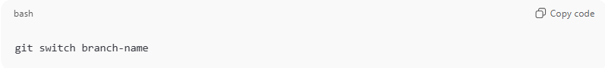
git switch branch-name
Example:
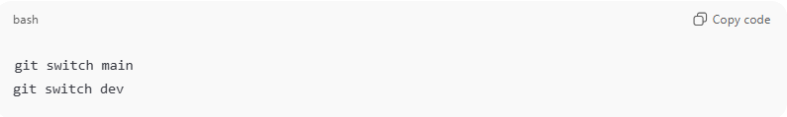
git switch main
git switch dev
Git will:
- Move HEAD to that branch
- Update your working directory files to match that branch

2. Create and switch to a new branch
# Source: AI Source: Provided by: [Data Path: Persons Table -> ID Column: 1, Name_En Column: Motasem Essam] -> From: [ChatGPT] on [2/15/2026]
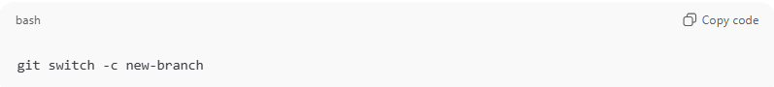
git switch -c new-branch
Example:
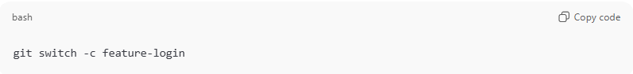
git switch -c feature-login
This:
- Creates a new branch
- Switches to it immediately

3. Switch to previous branch
# Source: AI Source: Provided by: [Data Path: Persons Table -> ID Column: 1, Name_En Column: Motasem Essam] -> From: [ChatGPT] on [2/15/2026]
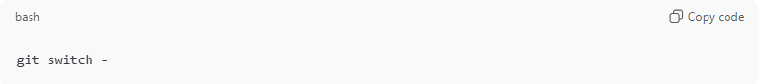
git switch -
This toggles between your last two branches.

switch vs checkout
# Source: AI Source: Provided by: [Data Path: Persons Table -> ID Column: 1, Name_En Column: Motasem Essam] -> From: [ChatGPT] on [2/15/2026]
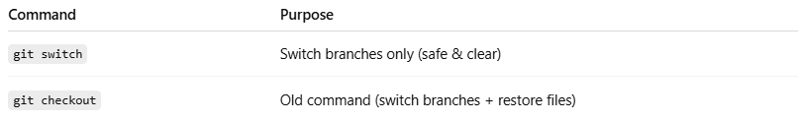
Command | Purpose
git switch | Switch branches only (safe & clear)
git checkout | Old command (switch branches + restore files)
Modern Git prefers:
- git switch → for branches
- git restore → for files

Important notes
# Source: AI Source: Provided by: [Data Path: Persons Table -> ID Column: 1, Name_En Column: Motasem Essam] -> From: [ChatGPT] on [2/15/2026]
- Git may refuse to switch if you have uncommitted changes that would be overwritten.
- You can force (danger ⚠️):
git switch -f branch-name

Quick summary
# Source: AI Source: Provided by: [Data Path: Persons Table -> ID Column: 1, Name_En Column: Motasem Essam] -> From: [ChatGPT] on [2/15/2026]
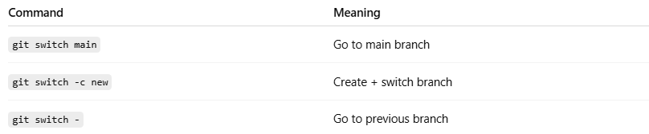
Command | Meaning
git switch main | Go to main branch
git switch -c new | Create + switch branch
git switch - | Go to previous branch

